Tiger Territory Back Packs

are now on sale.

Buy yours today to carry your HW folder, agenda,

gym clothes, and other items that you need everyday.

Cost: $10.00

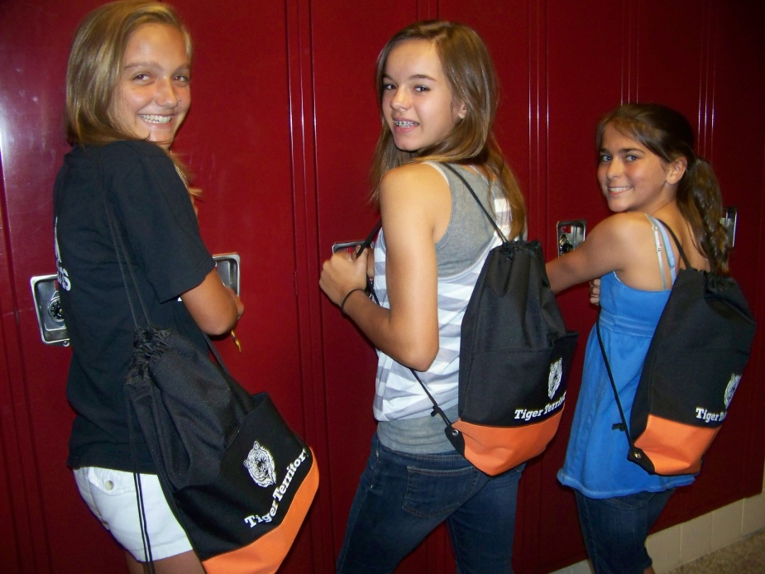

Return your order form and money to

Mrs. Carlson or the MS office!

Your Name ________________________________

Homeroom # __________

Total #of back packs _______

Total $ enclosed ___________ (cash or checks made out to Akron Middle School Government)